Ideation Phase
Empathize & Discover

Date | 27 JUNE 2025
Team ID | NM2025TMID00377
Project Name | Calculating Family Expenses using Service Now
Maximum Marks | 4 Marks

Empathy Map Canvas:
In the Empathize & Discover phase, the team observes how families struggle to track and manage their monthly expenses effectively. They learn that many family members feel overwhelmed when trying to monitor spending across multiple categories like groceries, utilities, education, healthcare, and entertainment. By interviewing families, they uncover that this issue causes financial stress, budget overruns, and difficulty in identifying spending patterns which leads to poor financial planning.
Gathering these insights helps the team see the real impact on family budgets and financial wellness. Understanding the families' daily challenges makes it clear that better expense categorization, spending alerts, budget tracking tools, and automated expense reports are needed. These discoveries will shape solutions that are practical and family-friendly.
Example:

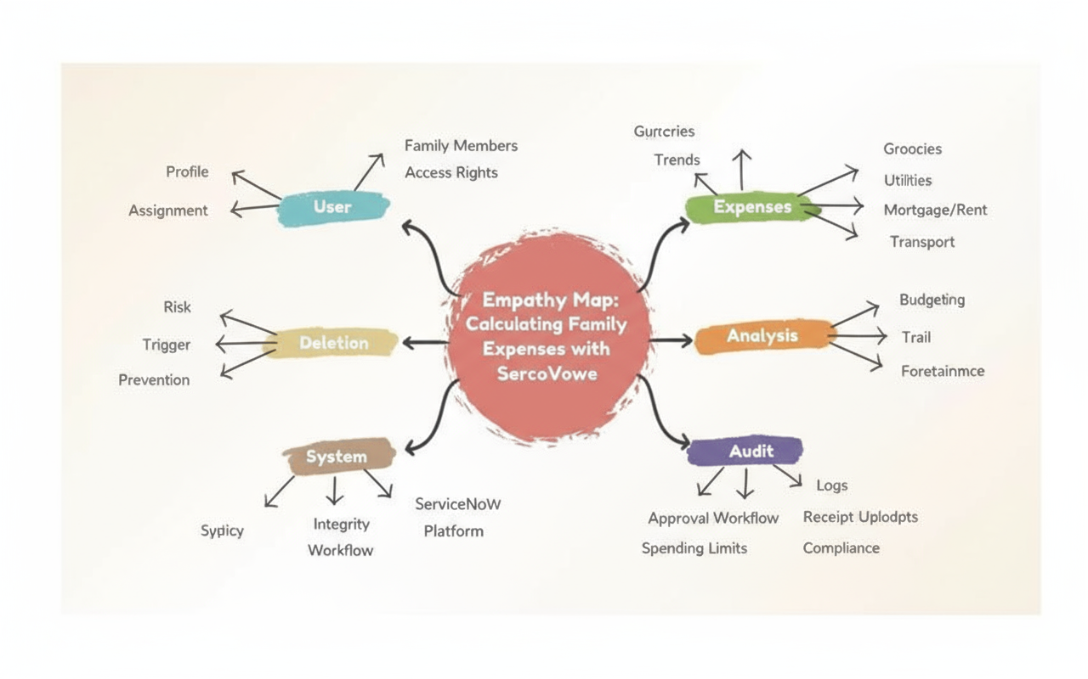
The empathy map helped us understand the challenges families face when tracking and managing their expenses. It reveals their pain points, daily actions, and needs for better financial visibility and control. This guided us to design a comprehensive system that enables families to monitor spending, set budgets, and make informed financial decisions.

Example: Family Expense Tracking System
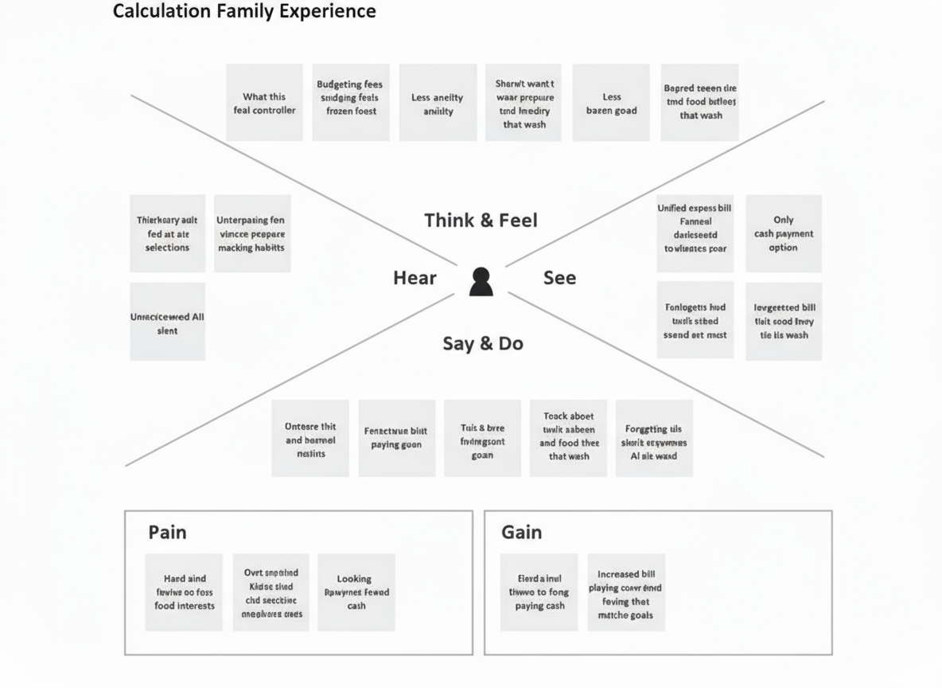

By deeply understanding families through empathy mapping, we identified the critical challenges and frustrations associated with tracking and managing household expenses. These insights revealed pain points such as lack of real-time spending visibility, difficulty categorizing expenses across multiple family members, and absence of budget alerts and overspending warnings. As a result, we designed a comprehensive and user-friendly system in ServiceNow that integrates automated expense categorization, real-time budget tracking, and customizable alerts. This ensures that families can monitor their spending effectively, identify cost-saving opportunities, and maintain financial health, thereby improving financial literacy, reducing money-related stress, and enhancing overall family well-being.

